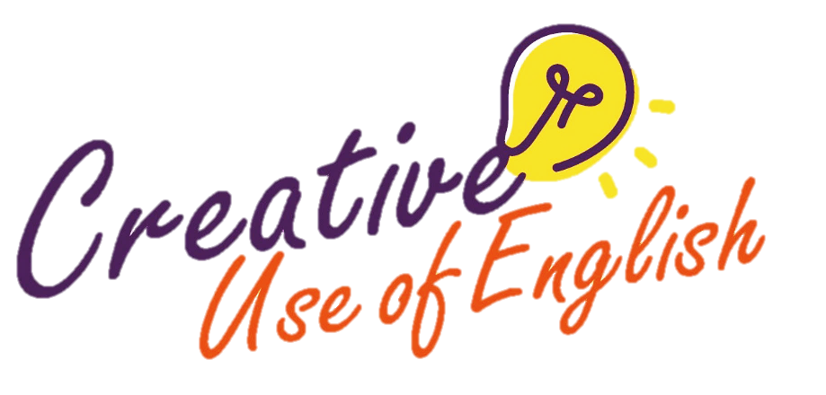

*Notes: Teachers may use the poster “Other Ways to EXPRESS…” to guide students to complete this part.*

|  |
| --- |
| 3. Use  to describe actions |
| *Add prepositional phrases to the underlined action verbs to provide further details about the feelings of the characters and the manner of the actions.* |
| When the finish line was in sight, the hare and the tortoise could hear the crowd **squealing** **with delight**. The cheering was heartening and the hare and the tortoise **pressed** **ahead** **with pride/with confidence/with all might**. When they finally crossed the finish line, the tortoise couldn’t believe his eyes. He **asked** the hare **in doubt/in surprise**, “Am I daydreaming? Have we won the race?” The hare **answered** **with certainty/without hesitation**, “Of course, we have!” They then hugged each other and **capered** **in bliss/in wild excitement/with great joy/in high spirits.** |

WITH fear, joy, sadness, delight, pride, excitement, respect, gratitude, disappointment, relief, hesitation, ease, difficulty, all might, certainty

IN anger, surprise, dismay, frustration, shock, regret, pain, grief, terror, doubt

OUT OF curiousity, jealousy, spite, fear, guilt

Prepositional phrases



Use these three strategies in combination to enliven the character(s) in action.

Curriculum Development Institute

Education Bureau HKSAR ©2022

Suggested answers only

**In the tale *The Tortoise and the Hare*, two animals challenge each other to a race to prove who is the fastest. Mid-race, the hare lies down to rest, certain that it will win. The tortoise, though slow, never gives up and crosses the finishing line ahead of the hare. Slow and steady wins the race, as the message of the story goes.**

* Re-write this story.
* Use the same characters but imagine that the tortoise and the hare team up to race against other contestants.
* Express a message through the telling of the story.
* Give your story a title.

*Writing topic taken from Paper 2 of the 2019 HKDSE English Language Examination © HKEAA*

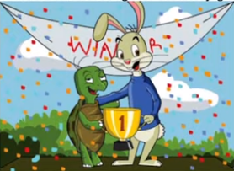

Different Ways to Describe Actions

**Topic**

|  |
| --- |
| *1. Use to add favour & express more ideas in fewer words* |
| *Replace the* ***underlined words*** *below with* ***vivid verbs****.* |
| The hare saw a noisy crowd gathering around the tree. He **went quickly** hurried/rushed/dashed to the tree to find out what was going on. The animals were talking excitedly about the poster on the trunk. He **read carefully** studied/examined the words on the poster and learnt that an obstacle pair race would be held soon. The hare **said softly** muttered/murmured/whispered to himself, “I must find the best partner and win the grand prize!” He **looked steadily** gazed/stared at the wide blue sky and started **thinking deeply about** pondering/ contemplating/considering who to team up with. |

Vivid verbs

***2. Use to   
describe actions***

Adverbs

|  |
| --- |
|  |
| *Add* ***adverbs*** *to the underlined action verbs to describe the mood of the characters and the manner of the actions.* |
| The obstacle race was a tough one – all the tougher for a slow and small tortoise! While the hare could **jump** **effortlessly/nimbly/easily/briskly** over the log hurdle, the tortoise could only **crawl** **clumsily/slowly** under it and had to be lifted by the hare. When they came to the monkey bars, the tortoise **frowned** **and** **sighed** **hopelessly/anxiously/worriedly** as he knew he could never get through. The hare **said** **warmly/confidently** to his partner, “Get onto my back!” Then, he **carefully/ strenuously** **moved** across the bars, making sure that the tortoise wouldn’t fall off. After climbing the monkey bars, the hare **was** **panting** **loudly/breathlessly/wearily**. |

MOOD: excitedly, warmly, confidently, eagerly, seriously, furiously, worriedly, hopelessly, thankfully, impatiently, relunctantly, wearily

MANNER: effortlessly, strenuously, breathlessly, swiftly, slowly, softly, loudly, gently, hard, abruptly